AWS Load Balancer & Auto Scaling Group – From Zero to Production (with Live Demos)
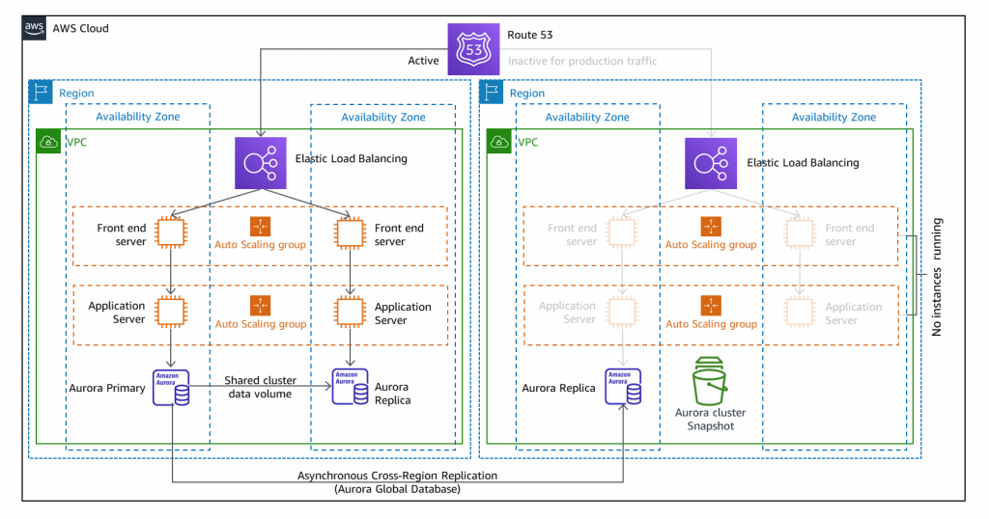
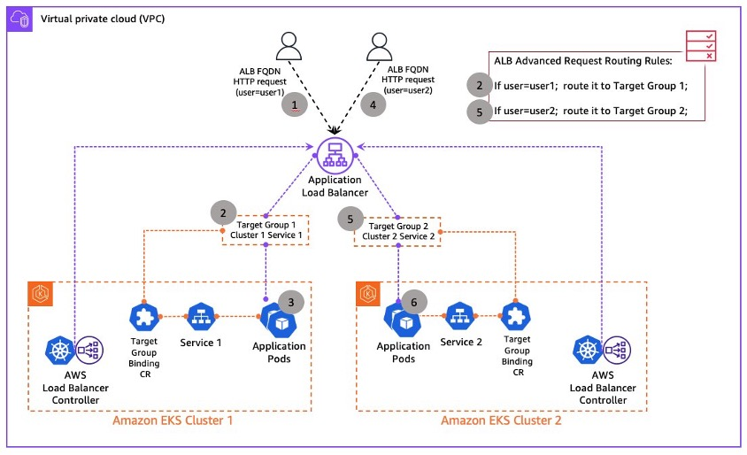
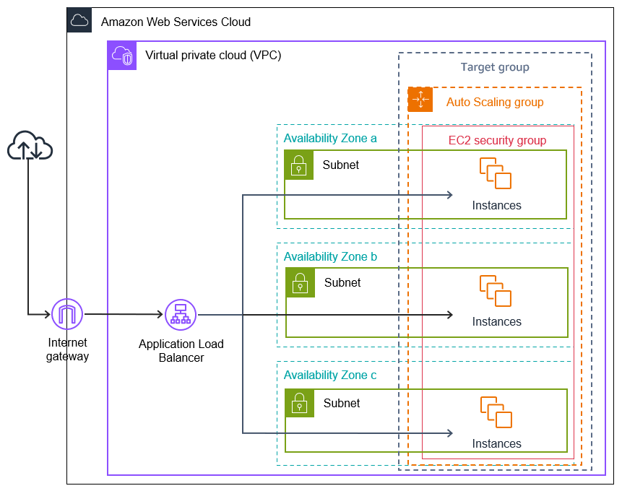
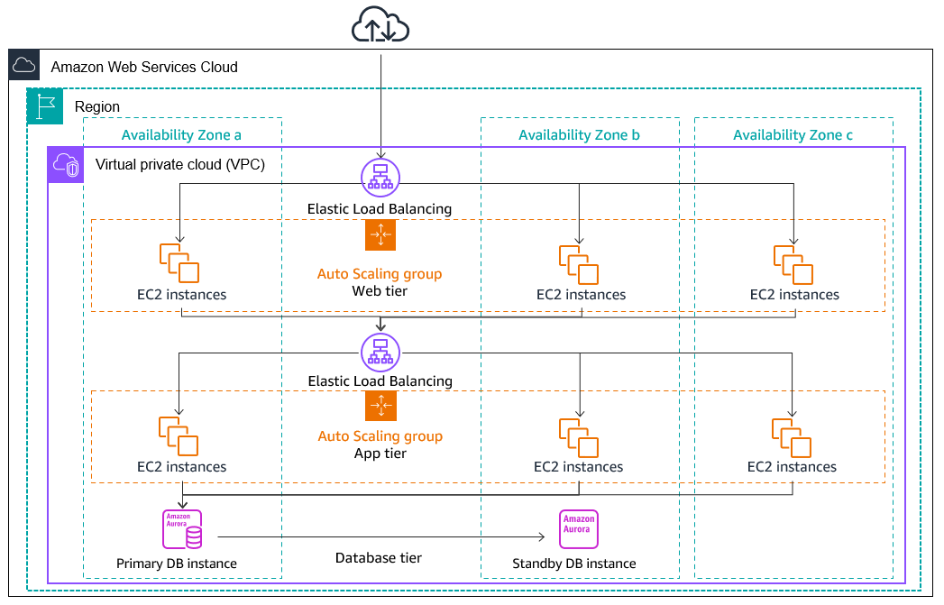

1️⃣ Session Flow (High Level)
Time | Topic
15 min | Why Load Balancer & ASG
30 min | Load Balancer deep dive
30 min | ASG deep dive
60 min | Live demos (step-by-step)
15 min | Real-world scenarios + Q&A

2️⃣ Why Load Balancer & ASG? (Problem Statement)
Explain with story (important for understanding):
“What happens if 1 EC2 crashes?
What if traffic suddenly becomes 10x?
What if users access from different AZs?”
Problems without LB & ASG
- Single EC2 = Single Point of Failure
- Manual scaling = slow + error-prone
- Uneven traffic = bad user experience
Solution
- Load Balancer → Distributes traffic
- Auto Scaling Group → Adds/removes EC2 automatically

3️⃣ AWS Load Balancer – Deep Dive
Types of Load Balancers
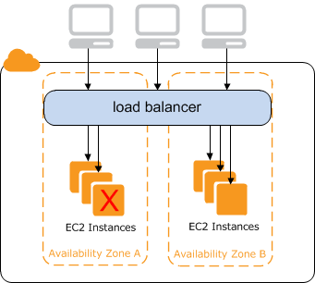
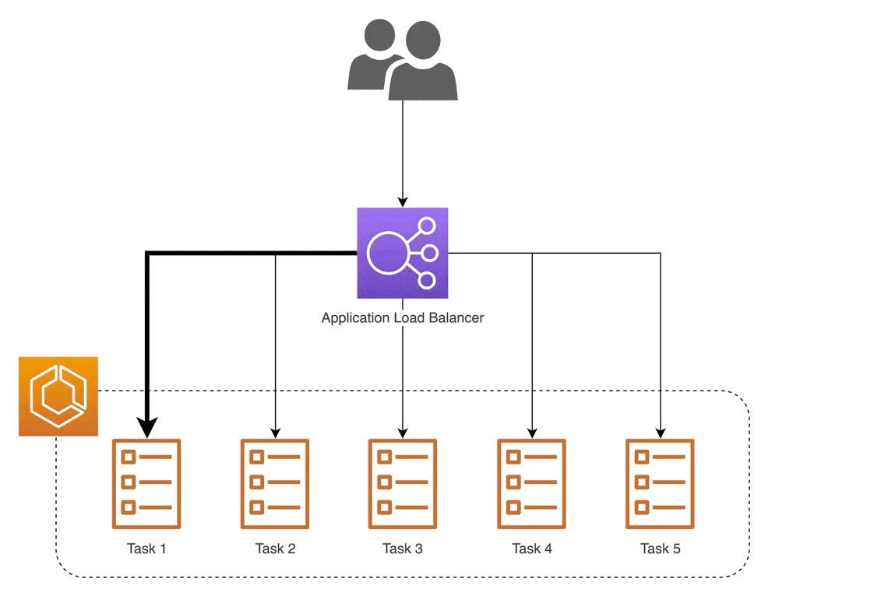
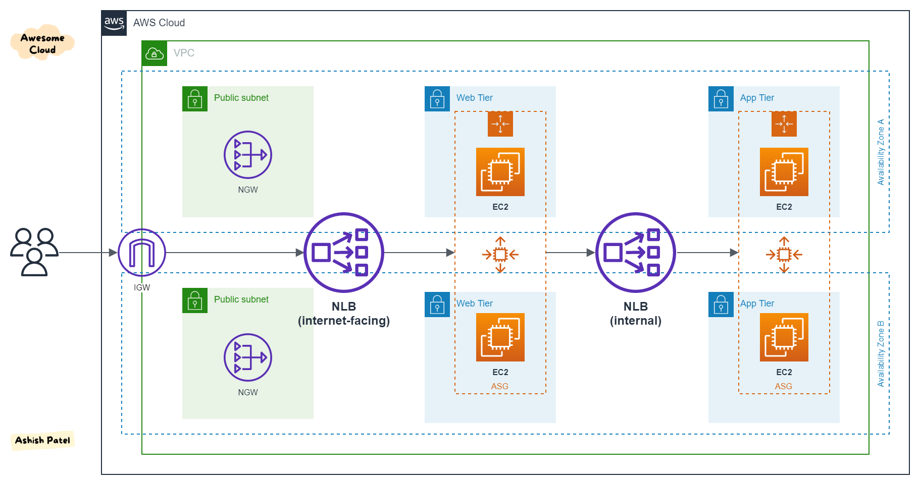
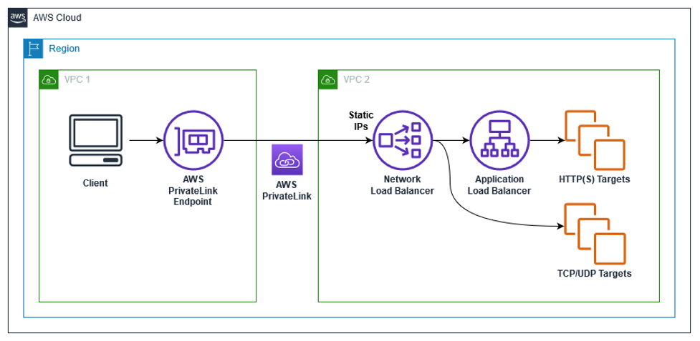
Type | Layer | Use Case
ALB | L7 | HTTP/HTTPS, path-based routing
NLB | L4 | High performance, TCP/UDP
CLB | L4/L7 | Legacy (avoid in new setups)
GWLB | L3 | Firewalls, security appliances
👉 Focus mainly on ALB (industry standard)

Key ALB Components
- Listener → Port + protocol (80 / 443)
- Target Group → EC2 / IP / Lambda
- Health Check → Determines healthy targets
- Rules → Path or host-based routing
Example:
/api → backend servers
/ → frontend servers

4️⃣ Auto Scaling Group – Deep Dive
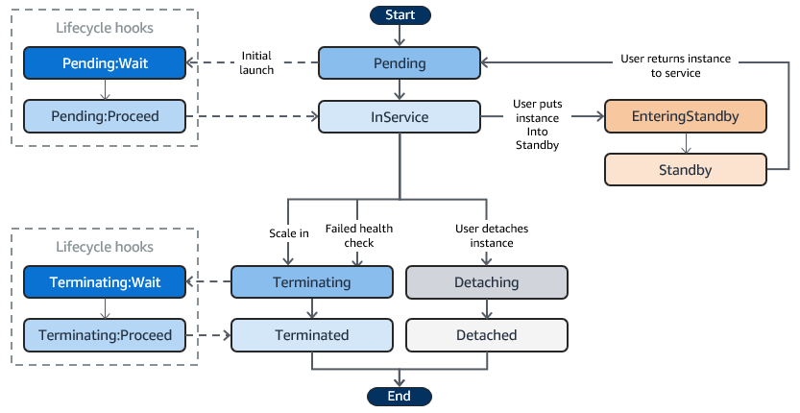
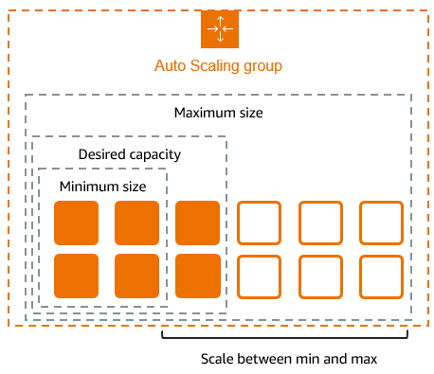
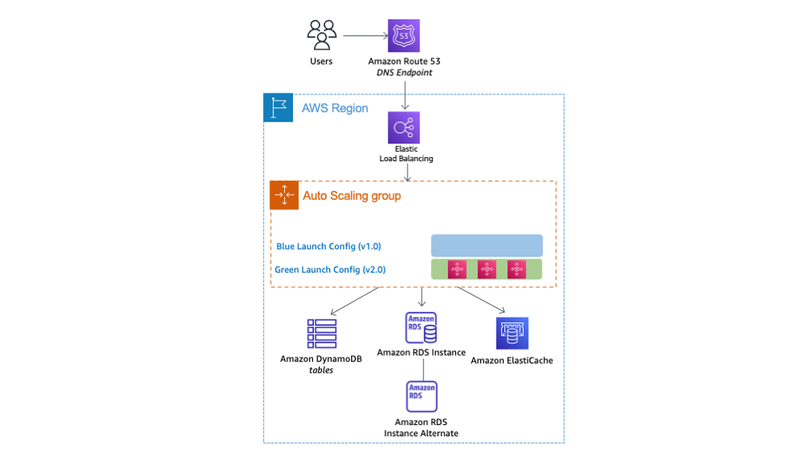
ASG Core Components
- Launch Template
- Min / Desired / Max capacity
- Scaling Policies
- Health checks (EC2 + ELB)
Scaling Types
Type | Explanation
Manual | You scale
Scheduled | Time-based
Dynamic | CPU / Request count
Predictive | ML-based (advanced)

5️⃣ LIVE DEMO – PART 1
Create EC2 + Web Server
Steps
- Launch EC2 (Amazon Linux 2)
- Security Group → allow HTTP : 80
- User Data:
#!/bin/bash
yum install -y httpd
systemctl start httpd
systemctl enable httpd
echo "Hello from $(hostname)" > /var/www/html/index.html
- Verify using Public IP
👉 Show page refresh → same hostname (single server)

6️⃣ LIVE DEMO – PART 2
Create Application Load Balancer
Steps
- EC2 → Load Balancers → Create ALB
- Internet-facing
- Select 2 AZs
- Listener → HTTP 80
- Create Target Group
  - Target type: EC2
  - Health check path: /
- Register EC2 instance
- Access ALB DNS
🎯 Demo Moment:
Refresh browser → traffic distribution

7️⃣ LIVE DEMO – PART 3
Auto Scaling Group Creation
Steps
- Create Launch Template
  - Same AMI
  - Same user data
- Create ASG:
  - Min: 1
  - Desired: 2
  - Max: 4
- Attach to Target Group
- Enable ELB health checks
🎯 Show:
- EC2 count automatically becomes 2
- Both registered in Target Group

8️⃣ LIVE DEMO – PART 4
Auto Scaling in Action (🔥 Best Part)
CPU-based scaling policy
- Target tracking → CPU 50%
Generate load
sudo yum install stress -y
stress --cpu 2 --timeout 300
🎯 Show:
- CPU spike
- New EC2 launched
- Auto registration with ALB

9️⃣ Failure Demo (Must Show)
- Manually terminate 1 EC2
- Observe:
  - ASG launches new instance
  - ALB health check replaces target
💡 Explain:
“Self-healing infrastructure”

🔟 Real-World Architecture
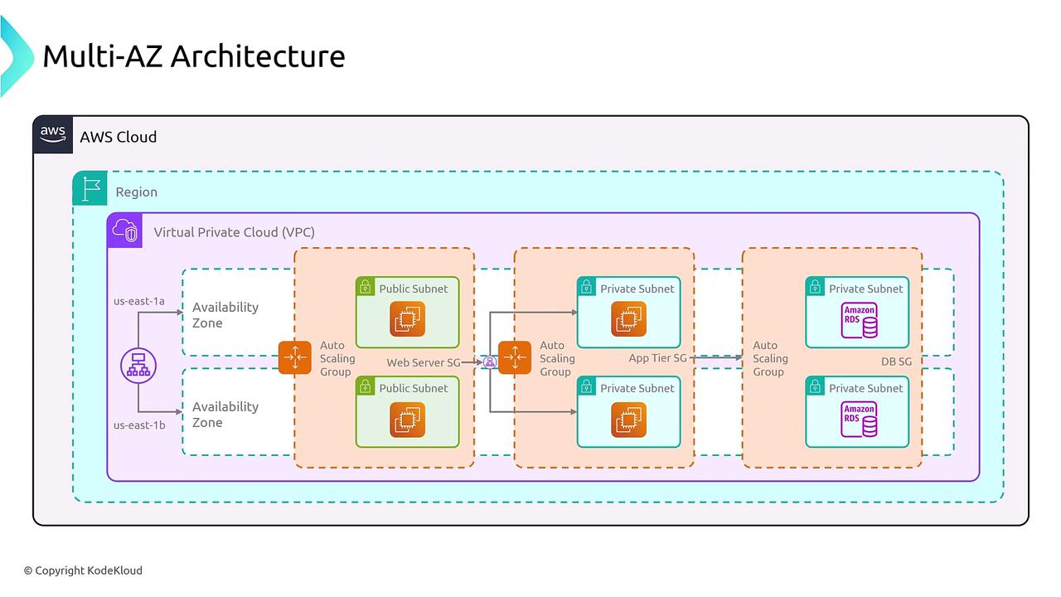
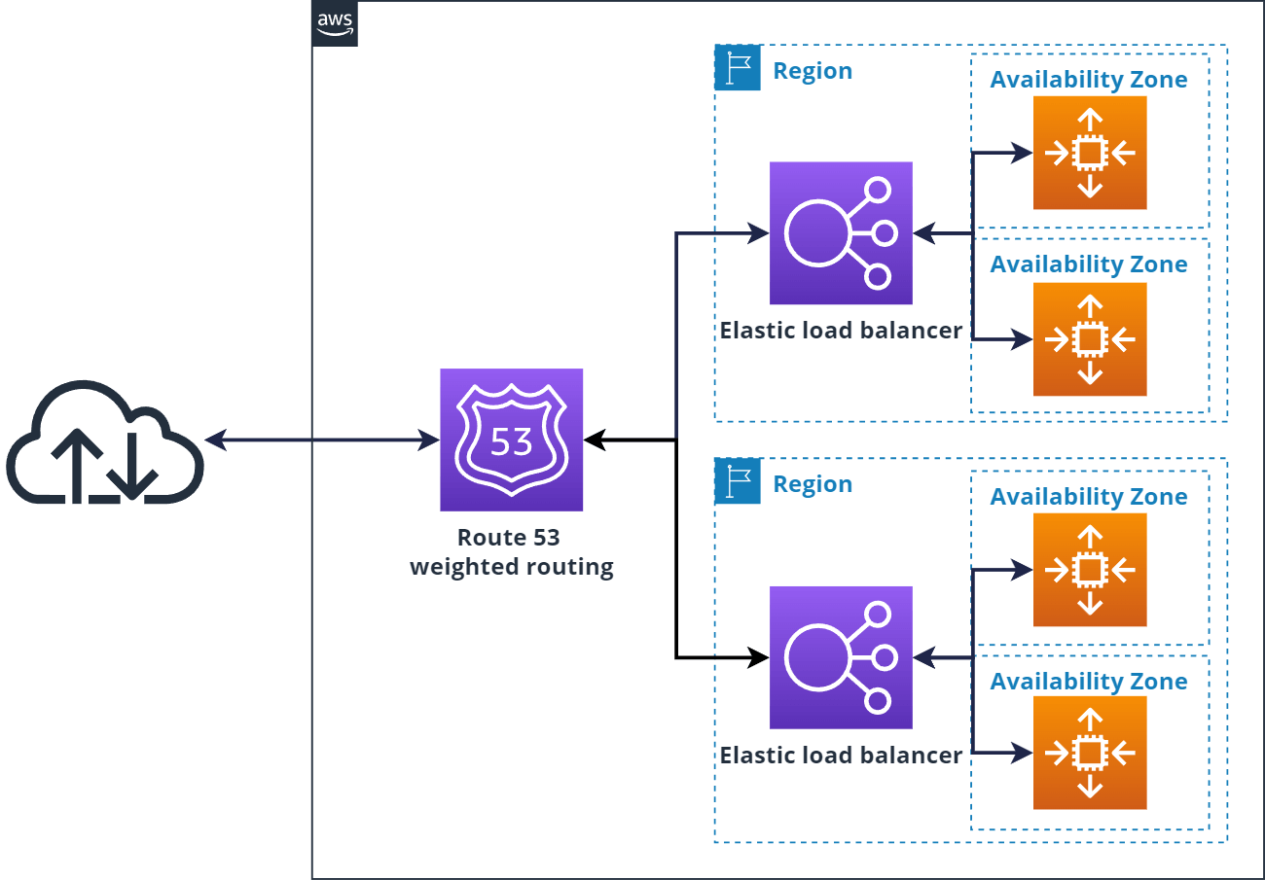
User
↓
ALB
↓
ASG (EC2 in AZ-a, AZ-b)

1️⃣1️⃣ Interview + Production Tips
- Always use Multi-AZ
- Enable connection draining
- Use HTTPS + ACM
- Scale on RequestCount, not only CPU
- Separate frontend & backend target groups

1️⃣2️⃣ Wrap-Up Summary
- Load Balancer = Traffic manager
- ASG = Automatic scaling + self healing
- Together = Highly Available & Scalable Architecture

Perfect question 👍
If someone doesn’t understand Launch Template, they never truly understand ASG.
Let’s build this slowly, concept-first, no AWS noise.

🚀 What is a Launch Template? (THE REAL MEANING)

🧠 Start With the Problem
Ask this in class:
“When Auto Scaling Group creates a NEW EC2,
how does AWS know what kind of EC2 to launch?”
It must know:
- Which AMI?
- Instance type?
- Security group?
- Key pair?
- User data?
- Storage?
👉 That full instruction set is Launch Template.

📦 Simple Definition (Memorable)
A Launch Template is a blueprint that tells AWS exactly HOW to create an EC2 instance.
If EC2 is a house,
Launch Template is the architect’s blueprint.

🧠 Why ASG Cannot Work Without It
Auto Scaling Group’s job:
- Maintain desired capacity
- Replace failed instances
- Scale in/out
But ASG does not know EC2 details.
So:
ASG says: “I need 1 more server”
Launch Template says: “Here’s how to build it”

🧱 What a Launch Template Contains (Conceptual)
Think of it as EC2 launch form saved forever.
Component | Purpose
AMI | OS + app
Instance type | CPU & memory
Key pair | SSH access
Security groups | Network rules
User data | Bootstrap script
Storage | EBS config
IAM role | Permissions

🧠 IMPORTANT: Launch Template vs Launch Configuration
Old Way (Deprecated)
- Launch Configuration ❌
- Cannot edit
- No versioning
Modern Way
- Launch Template ✅
- Versioned
- Reusable
- Supports Spot, Mixed Instances
👉 AWS exam + production = Launch Template only

🔢 Versioning (CRITICAL CONCEPT)
Launch Template is versioned.
Example:
- v1 → Amazon Linux + t2.micro
- v2 → Amazon Linux + t3.micro
- v3 → New AMI
ASG can use:
- Latest version
- Specific version
🎓 Teaching line:
“Launch Template lets you change future servers without touching existing ones.”

🧠 Why User Data is SO Important Here
Every new EC2 created by ASG runs User Data automatically.
That means:
- Install software
- Pull code
- Start services
Example:
#!/bin/bash
yum install -y httpd
systemctl start httpd
👉 Stateless server philosophy

🧠 Launch Template in Real Architecture
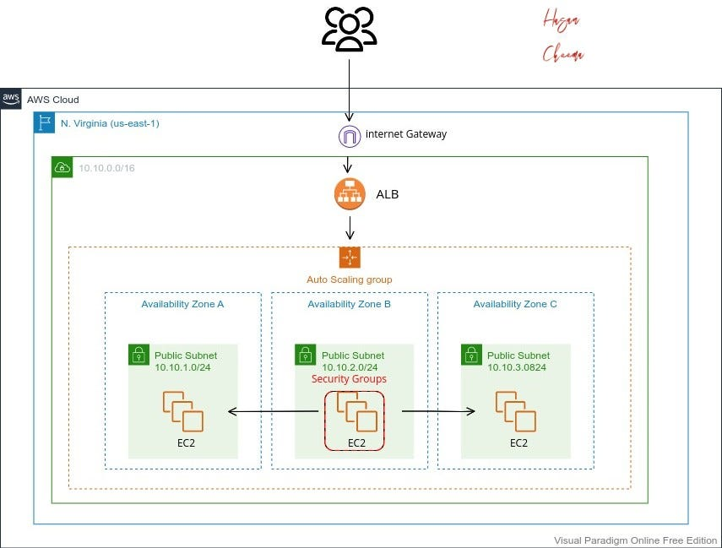
Launch Template → ASG → EC2
↓
Target Group
↓
ALB

🧠 Common Confusions (Clear Them)
❓ “Is Launch Template an EC2?”
- ❌ No
- It only describes EC2
❓ “Can I launch EC2 directly from it?”
- ✅ Yes
❓ “Does changing template affect running EC2?”
- ❌ No (only new ones)

🎯 Interview-Ready Answer
“A Launch Template is a reusable and versioned configuration that defines how EC2 instances are launched, and it is used by Auto Scaling Groups to dynamically create and replace instances.”

🧠 One-Liner to Drill Into Minds
“ASG decides WHEN to create servers,
Launch Template decides HOW to create them.”

Great — this is core ASG theory and very interview-heavy 👍
I’ll explain it concept → why → types → when to use, so it actually makes sense.

🔄 Types of Auto Scaling Policies (Clear & Practical)

🧠 First: What is a Scaling Policy?
A scaling policy tells an Auto Scaling Group WHEN and HOW MUCH to scale.
ASG already knows:
- HOW to create EC2 → Launch Template
Policy decides:
- WHEN to add/remove
- HOW MANY to add/remove

1️⃣ Target Tracking Scaling (MOST USED ✅)
Concept
“Maintain a metric at a target value.”
Example:
Keep average CPU at 50%
AWS automatically:
- Scales out when CPU > 50%
- Scales in when CPU < 50%

Example Metrics
- CPUUtilization
- ALB RequestCountPerTarget
- Custom CloudWatch metrics
🎓 Teaching line:
“You tell AWS the goal, AWS does the math.”

When to Use
✅ Web applications
✅ Unpredictable traffic
❌ Precise scaling control needed

2️⃣ Step Scaling (CONTROL-HEAVY)
Concept
“Scale in steps based on threshold ranges.”
Example:
CPU 60–70% → add 1
CPU 70–90% → add 2
CPU > 90% → add 3

Why It Exists
- Gives fine-grained control
- Avoids over-scaling

When to Use
✅ Predictable traffic
✅ Known performance behavior
❌ Beginners (complex)

3️⃣ Simple Scaling (LEGACY ❌)
Concept
“One alarm → one scaling action.”
Example:
CPU > 70% → add 1
CPU < 30% → remove 1
⚠️ Has cooldown blocking
⚠️ AWS discourages it

Interview Tip
“Simple scaling exists but is not recommended.”

4️⃣ Scheduled Scaling (TIME-BASED)
Concept
“Scale at a specific time.”
Example:
Scale to 10 instances at 9 AM
Scale to 2 instances at 10 PM

When to Use
✅ Known traffic patterns
- Office hours
- Sales events
- Batch jobs
❌ Random traffic

5️⃣ Predictive Scaling (ADVANCED 🤖)
Concept
AWS analyzes historical data and predicts future traffic.
Example:
- Learns Monday morning spike
- Scales before traffic arrives

Requirements
- Stable traffic patterns
- Enough historical data

When to Use
✅ Large-scale apps
❌ Small / new systems

🧠 Scaling Policy Comparison (One Slide)
Policy Type | Best For | Control | AWS Automation
Target Tracking | Most apps | Low | High
Step Scaling | Advanced control | High | Medium
Simple Scaling | Legacy | Low | Low
Scheduled | Known times | Medium | Medium
Predictive | Enterprise | Low | Very High

🎯 Interview-Perfect Answer
“Auto Scaling supports target tracking, step scaling, simple scaling, scheduled scaling, and predictive scaling. Target tracking is the most commonly used because it automatically maintains a desired metric value.”

🧠 One-Line Memory Hook
“Target tracking = maintain
Step scaling = control
Scheduled = time
Predictive = AI”

